EFFICENT N QUEEN PROBLEM

NAME: J.L.PUGAZH MUKILAN

REG NO: 22BCE9292 SLOT :L7+L8

1)solve the n queen problem with least number of moves

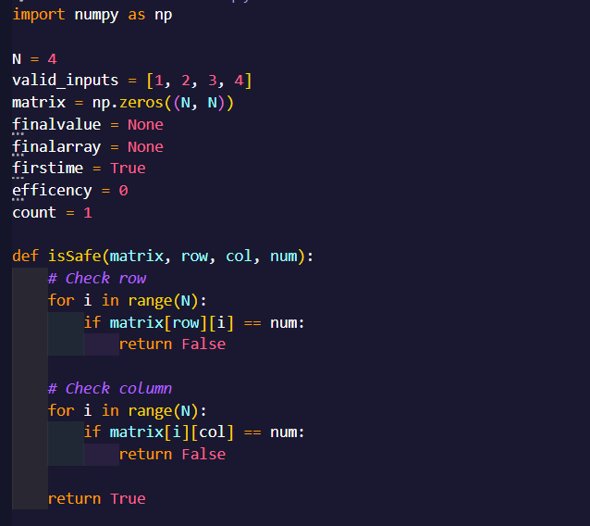

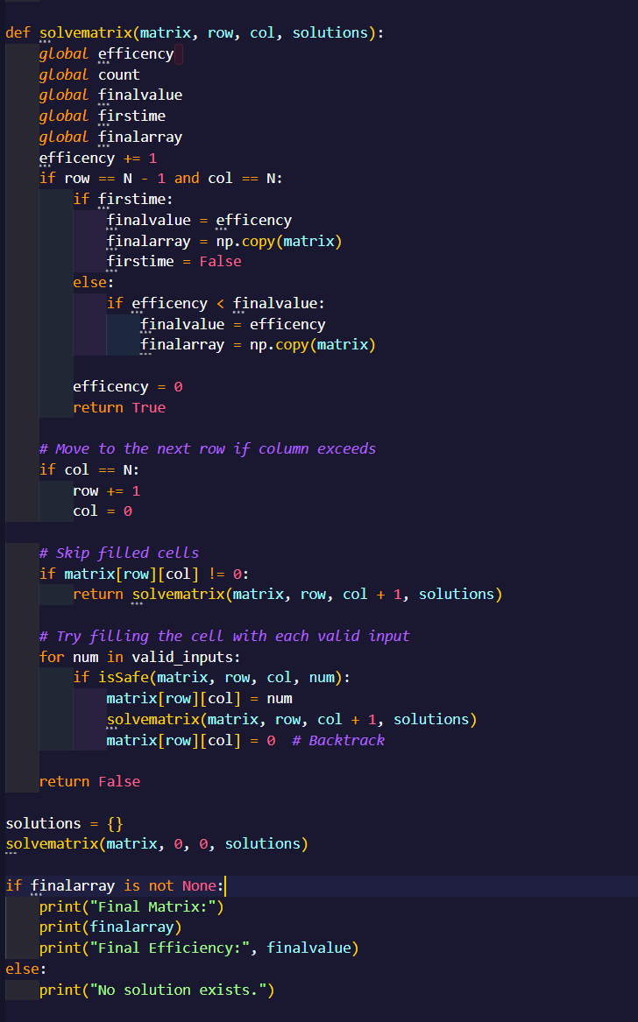

OUTPUT:

